Suffer with migraines? Female sufferers 'more likely' to DIE from heart disease and stroke

WOMEN who suffer from migraines have higher risk of heart attacks and strokes - and are more likely to die from them, scientists have warned.

By [OLIVIA LERCHE](http://www.express.co.uk/search/Olivia+Lerche?s=Olivia+Lerche&b=1)

PUBLISHED: 23:30, Tue, May 31, 2016

A migraine is a severe headache where people experience a throbbing pain at the front or side of the head.

They are also often accompanied with other symptoms, such as nausea, vomiting and increased sensitivity to light or sound.

Migraines affect around one in every five women and around one in every 15 men.

A study published in The British Medical Journal (BMJ) found women who sufferer from migraines have a slightly increased risk of developing cardiovascular diseases.

Scientists from Germany and the US said migraine should be treated as a risk factor for the disease.

But statins and Vitamin D - made by the skin in reaction to sunshine and found in oily fish such as salmon, sardines and mackerel, eggs, and fortified fat spreads and breakfast cereals - could stop migraines occurring..

Migraines have been consistently linked with an increased risk of stroke, but few studies have shown an association of migraine with cardiovascular diseases and mortality.

Professor Tobias Kurth of the Charita University Hospital Berlin said: "To date, no clear mechanisms have been identified that could explain the increased risk of cardiovascular disease and mortality among patients with migraine, and no data exist on whether prevention of migraine attacks reduces these risks.

"Data from the National Health and Nutrition Examination Survey and results of a randomised clinical trial provide initial evidence that the combination of a statin and vitamin D may reduce the burden of migraine, which may be explained by the anti-inflammatory effects of these drugs.The study evaluate associations between migraine, cardiovascular disease and mortality by analysing data from 115,541 women enrolled in the Nurses' Health Study II.

They were aged 25 to 42 years and did not have angina and cardiovascular disease who were followed over 20 years for cardiovascular events, diseases and mortality.

Overall, 17,531 (15.2 per cent) women were diagnosed with migraine at the start and 1,329 total cardiovascular disease events occurred and 223 women died due to cardiovascular disease during the follow up.

When compared with participants without migraine, those with migraine had anelevated risk of myocardial infarction, angina, or coronary revascularization and of cardiovascular mortality.

The relative risk for the combined outcome of all those events or stroke was roughly 50 per cent higher than that for women without migraine, an effect not modified by age.

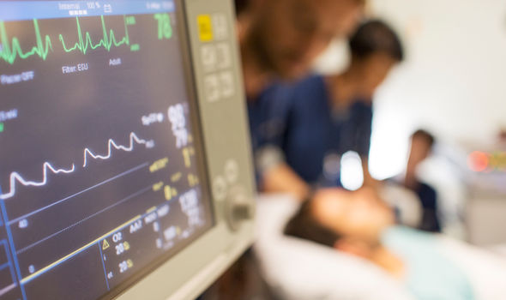

GETTY

Experts say future research is urgently warranted

The fight against Zika virus

Mon, August 1, 2016

The Zika virus, an infectious disease linked to severe birth defects in babies, is still being fought.

|  |  |  |  |  |  |  |  |  |  |  |  |  |
| --- | --- | --- | --- | --- | --- | --- | --- | --- | --- | --- | --- | --- |
| |  |  |  | | --- | --- | --- | |  |  |  | |  |  |  | |  |  |  | |  |  |  | |

**PLAY SLIDESHOW**

Professor Kurth added: ”Future targeted research, such as on whether statins and vitamin D reduce the burden of migraine and cardiovascular disease, is urgently warranted to provide answers to patients and their treating physicians.

"Results of this large, prospective cohort study among women support the hypothesis that migraine is a marker for increased risk of any cardiovascular events.

"Given the high prevalence of migraine in the general population, an urgent need exists to understand the biological processes involved and to provide preventive solutions for patient."

He added: "These results further add to the evidence that migraine should be considered an important risk marker for cardiovascular disease, at least in women."

In a linked editorial, Rebecca Burch from Harvard Medical School and Melissa Rayhill from The State University of New York at Buffalo said the magnitude of the risk should not be ‘over-emphasised’, as ‘it is small at the level of the individual patient, but still important at a population level because migraine is so prevalent’.